Test Case: tc001_SPX_Dev5_Crear_Solicitud_Articulo_Almacen
Step 1 - Enter username and password and click to button Enter : Credentials Entered
Image file-name: QC_Testing-tc001_SPX_Dev5_Crear_Solicitud_Articulo_Almacen-1787932949368

Step 2 - Select to UEN and Access to Request for a New Inventory Item : UEN Correctly selected and Correct access
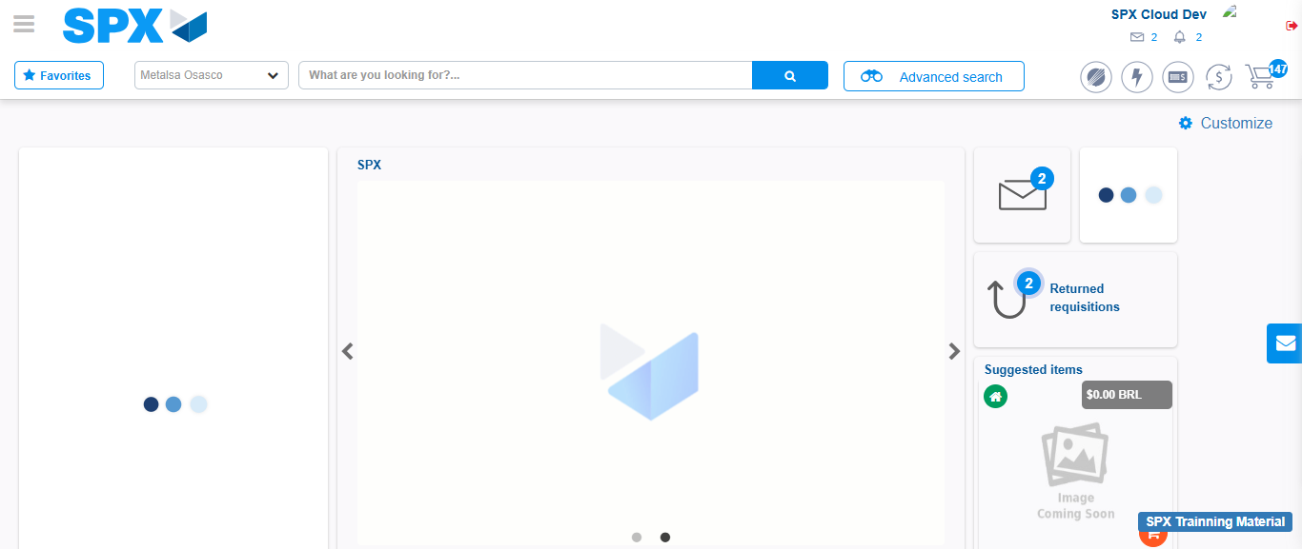Image file-name: QC_Testing-tc001_SPX_Dev5_Crear_Solicitud_Articulo_Almacen-1787932981140

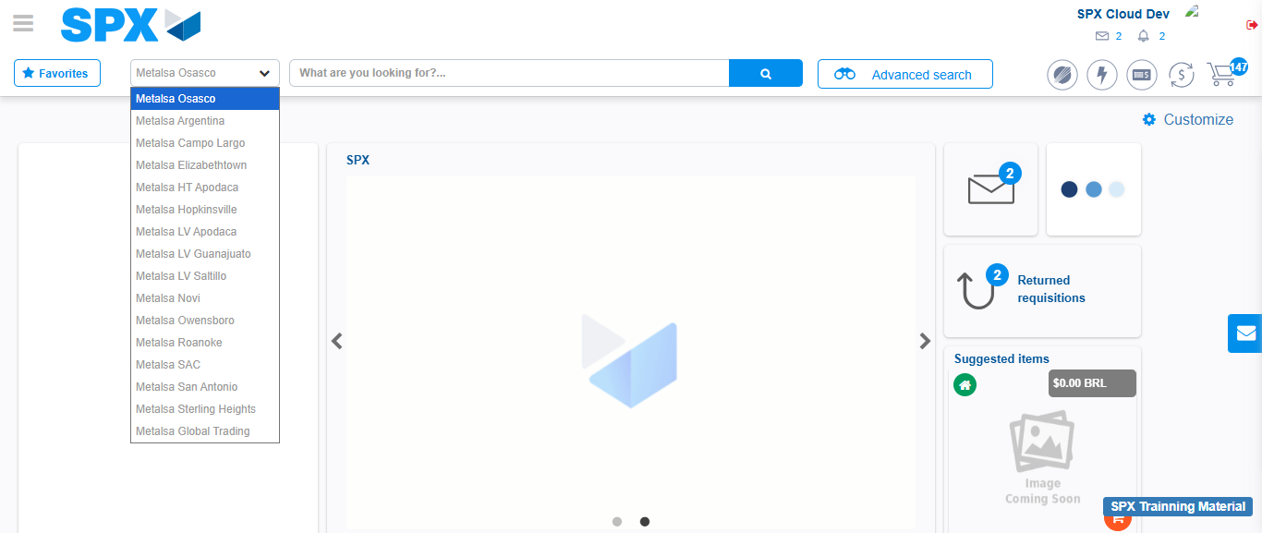Image file-name: QC_Testing-tc001_SPX_Dev5_Crear_Solicitud_Articulo_Almacen-1787932981786

Image file-name: QC_Testing-tc001_SPX_Dev5_Crear_Solicitud_Articulo_Almacen-1787932996327

Step 3 - Select options first section : Options seleted correctly
Image file-name: QC_Testing-tc001_SPX_Dev5_Crear_Solicitud_Articulo_Almacen-1787932996532

Image file-name: QC_Testing-tc001_SPX_Dev5_Crear_Solicitud_Articulo_Almacen-1787932996659

Step 4 - Select options at Screen: Options seleted correctly
Image file-name: QC_Testing-tc001_SPX_Dev5_Crear_Solicitud_Articulo_Almacen-1787932996532

Image file-name: QC_Testing-tc001_SPX_Dev5_Crear_Solicitud_Articulo_Almacen-1787932996659

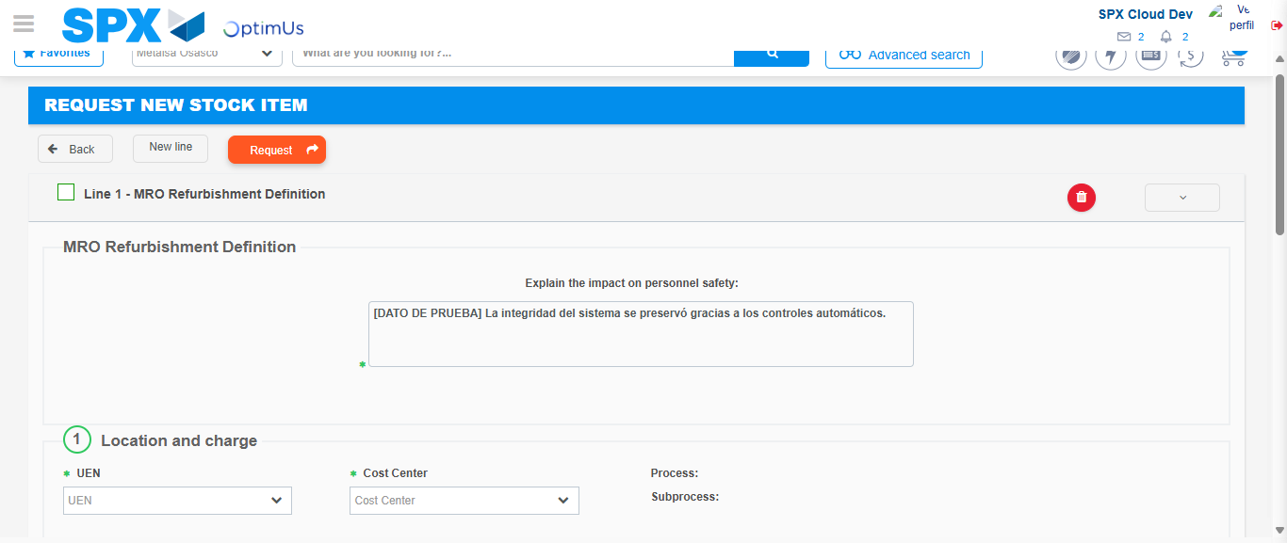Image file-name: QC_Testing-tc001_SPX_Dev5_Crear_Solicitud_Articulo_Almacen-1787933003014

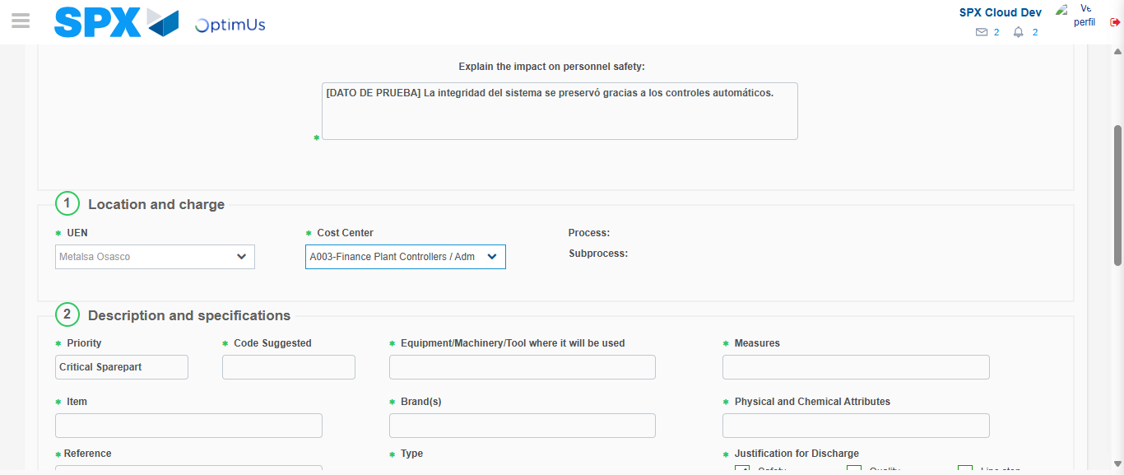Image file-name: QC_Testing-tc001_SPX_Dev5_Crear_Solicitud_Articulo_Almacen-1787933005914

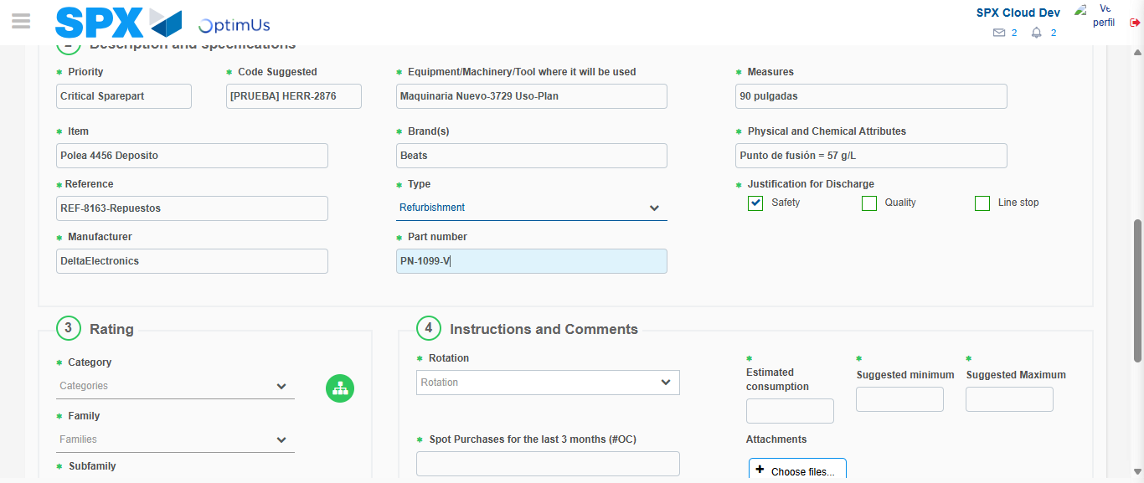Image file-name: QC_Testing-tc001_SPX_Dev5_Crear_Solicitud_Articulo_Almacen-1787933007655

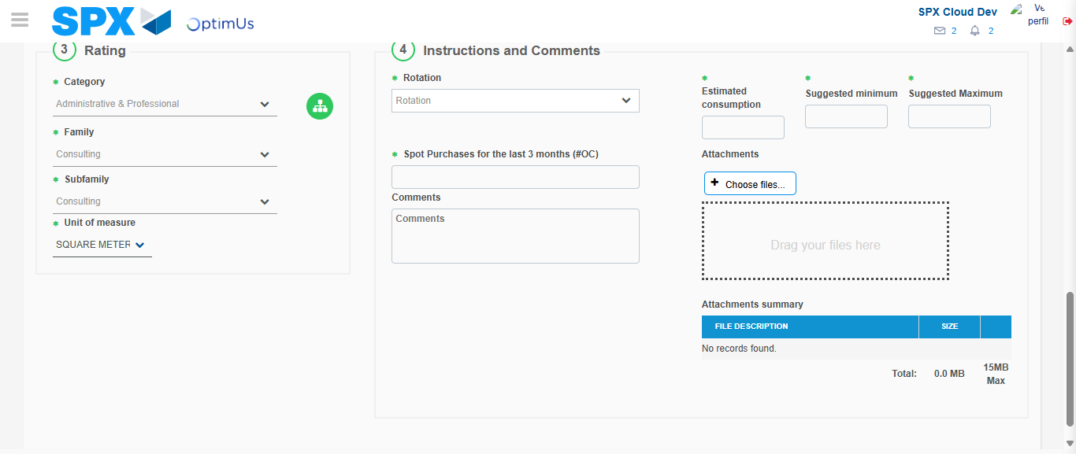Image file-name: QC_Testing-tc001_SPX_Dev5_Crear_Solicitud_Articulo_Almacen-1787933012394

Step 5 - Request New Item : Request Accepted
Image file-name: QC_Testing-tc001_SPX_Dev5_Crear_Solicitud_Articulo_Almacen-1787932981140

Image file-name: QC_Testing-tc001_SPX_Dev5_Crear_Solicitud_Articulo_Almacen-1787932981786

Image file-name: QC_Testing-tc001_SPX_Dev5_Crear_Solicitud_Articulo_Almacen-1787932996327

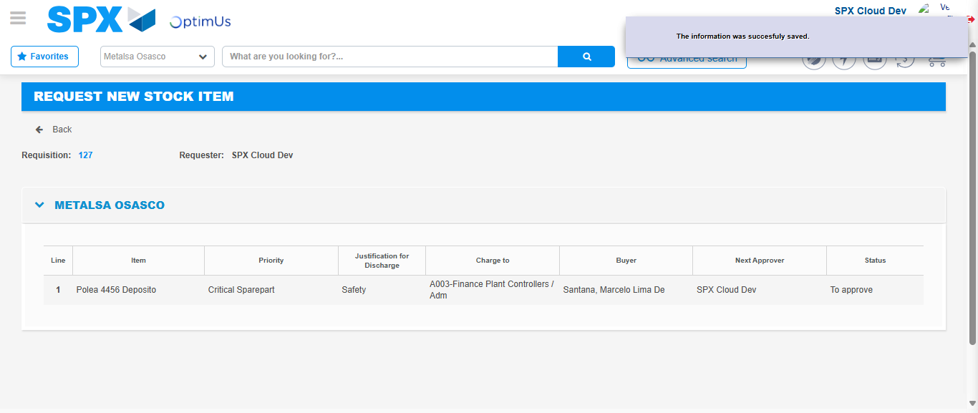Image file-name: QC_Testing-tc001_SPX_Dev5_Crear_Solicitud_Articulo_Almacen-1787933019245

Image file-name: QC_Testing-tc001_SPX_Dev5_Crear_Solicitud_Articulo_Almacen-1787933019422

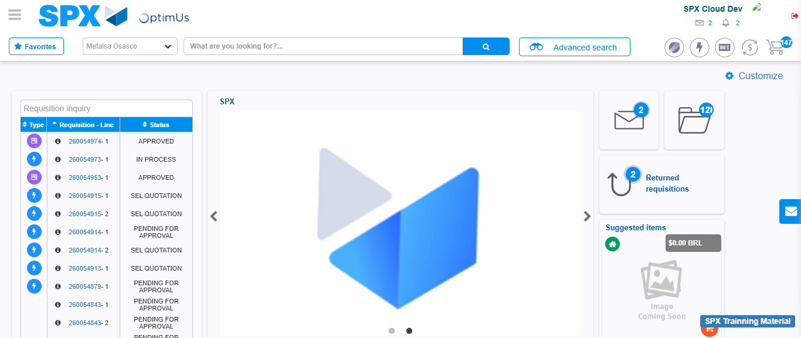Image file-name: QC_Testing-tc001_SPX_Dev5_Crear_Solicitud_Articulo_Almacen-1787933040770

Step 7 - Return to Main Page SPX : Return to Main Page SPX
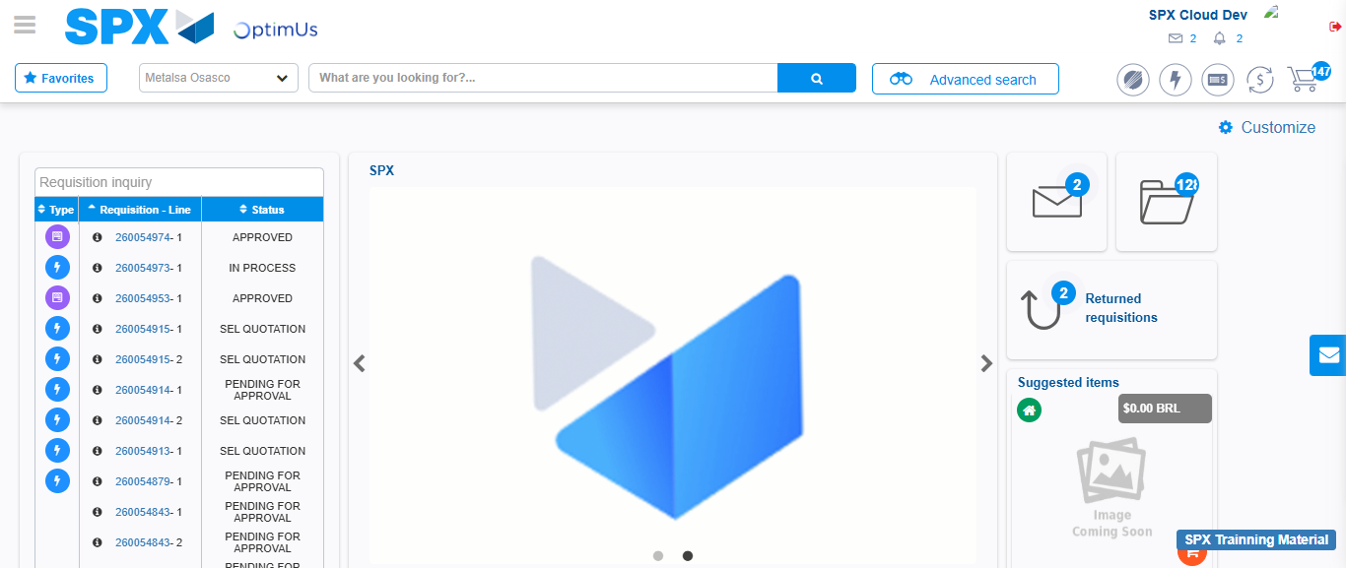Image file-name: QC_Testing-tc001_SPX_Dev5_Crear_Solicitud_Articulo_Almacen-1787933041151

